Manual Tracking
Author: | Fabrice Cordelières, Institut Curie, Orsay (France).  fabrice.cordelieres at curie.u-psud.fr
History: | 2004/06/25: First version  2005/06/15: New features: 2D centring correction, Directionality check, Previous track files may be reloaded, 3D features added (retrieve z coordinates, quantification and 3D representation as VRML file).
Requirements: | ImageJ 1.34k or later
Source: | Manual_Tracking.java
Installation: | Download Manual_Tracking.class to the plugins folder and restart ImageJ. Documentation in pdf format may be downloaded here.
Description: | This plug-in allows the user to quantify movement of objects between frames of a temporal stack, in 2D and 3D.  Results table:  This plug-in provides a way to retrieve in a table (figure 1) XY and XYZ coordinates as well as velocity, distance covered between two frames and intensity of the selected pixel or volume, by simply clicking on the structure of interest.  Figure 1:  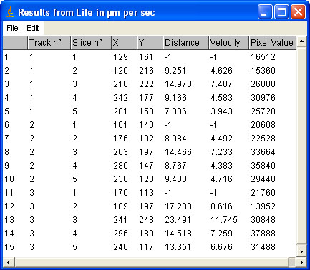  Note: as the first velocity value can't be calculated (first tracked frame where time interval equals zero), its first displayed value will be -1, as in most of the commercial software.  Interface:  Figure 2:  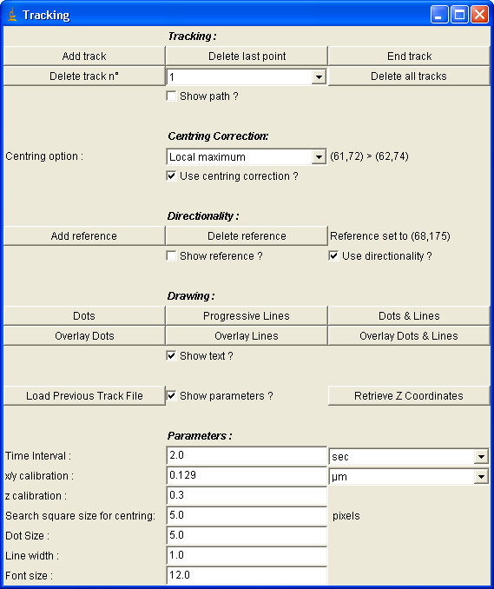  The interface is composed of 5 parts:  - Tracking buttons:  - To start recording one track, the user has to click on "add track".  - The tracking is done by clicking on the structure on the image. After each mouse click, the following image of the temporal stack is activated until the last image is reached or the "End track" button is pressed.  - "Delete last point" is used to erase the last recorded coordinates.  - "End track" button should be used to stop the tracking procedure in case the structure disappeared from the image.  - By selecting the number in the list next to the "Delete track n°" button, the user is allowed to erase one track from the result table. This choice should be validated by clicking on the "Delete track n°" button.  - "Delete all tracks" is used to clean up the results table.  - Centring correction: helps the user to point the right pixel.  - Directionality: retrieves information on whether the movement is retrograde or anterograde.  - Drawing: this section deals with the ways to get a visual representation of the coordinates recorded in the results table. Several displays are available: each button's function is illustrated in the following section  - Parameters: this section contains all required calibration values and drawing settings.  Display:  The Manual Tracking module has display capacities aiming to provide either a synthetic vision of the tracked points and/or their paths (figure 3, top), or an overlay of one of the synthetic representations and the original image (figure 3, bottom).  Figure 3:  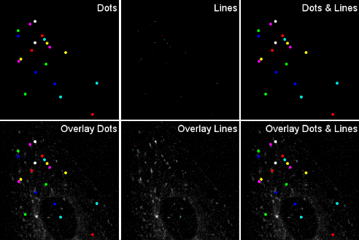  Retrieve z coordinates:  The Manual Tracking module was improved to allow a simple retrieval of z coordinates. This operation may be monitored by generating a VRML file of the 3D+time dataset (Figure 4) which can be viewed in any web browser equipped with the appropriate plug-in (see documentation for more details).  Figure 4:  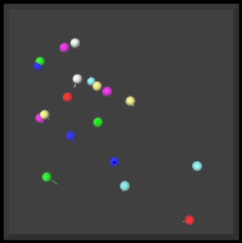
|Plugins| Home |

